Insert company Logo
COMPANY NAME

Policy Name: | Induction Policy
Policy Number:
Version: |  | Effective Date:

 | Name | Designation | Signature | Date
Prepared By:
Reviewed By:
Approved By:

Date | Version | Summary of Change

Table of Contents

1. DEFINITION 3
2. PURPOSE 3
3. APPLICABILITY 3
4. RESPOSIBILITY & ACCOUNTABILITY 3
5. POLICY 3
A. Induction Process 4
1. Pre Joining/ Paperwork Process 4
2. Induction Session 4
3. Introduction with other Employees and Departments 5
4. Induction Information/ Joining Kit 5
5. Asset and Workstation Allocation 5
6. Employee Induction Checklist 6
6. RESTRICTIVE CLAUSE 6
7. ANNEXURE 1- Employee Induction Checklist 6

DEFINITION

- Induction is the action or process of inducting someone to a post or organization. Induction creates a sense of belongingness to the new employee and make the career shift effective and meaningful.
- Company/ Organization means all the businesses which are under the umbrella of “Company Name” group.
- Member/ Employee means a person employed with “Company Name” at all levels for wages or salary.
- Management means the group of individuals that operate at the higher level at “Company Name” and have day-to-day responsibility for managing all individuals and maintaining responsibility for all the key business functions.

PURPOSE
- To ensure that employee induction is dealt with in an organized and consistent manner.
- To enable staff to be introduced into a new post and working environment quickly, so that they can contribute effectively as soon as possible.

APPLICABILITY

The policy is applicable to all members of the “Company Name” across all the locations and branches.

RESPOSIBILITY & ACCOUNTABILITY
Human Resource Department, Learning and Development, Trainer, Reporting Manager.

POLICY

This induction policy, associated procedures and guidelines aim to set out general steps for employees to follow during the induction process.

All the new joinees will be properly and full inducted. It is imperative that all employees undergo the HR Induction program on day of joining and the full-fledged induction program in a months’ time.

Induction Process

Pre Joining/ Paperwork Process

This process involves new workplace participants completing necessary paperwork, to ensure the new workplace participant can be established on “Company Name” database. This should occur on the first day of the workplace participant's employment/engagement.
The paperwork includes completing:
- Acceptance on Offer letter and Terms and conditions
- Contact details
- Details of banking information
- Superannuation documentation
- Tax file number declaration
- Employee Details Form
- Tax File Declaration Form
- Statutory Compliance Forms
- Receipt of Personal, Educational and Professional experience documents along with photographs.

All the documents and paperwork to be kept in secure personnel file.

Induction Session
The session involves an induction session which is typically conducted by HR/ Trainer or Reporting Manager
The induction session will typically cover:
- A brief history of “Company Name”
- Company Locations/ branches/ Factories.
- A general outline of APIC’s Strategic Plan: the vision, mission and value statements
- The future directions of the business
- An outline of the various units/departments in the organization
- Quality management system.
- A training session on the Staff Code of Conduct Policy and expectations of professional behavior.
- Workplace health and safety, including the emergency evacuation procedure, location of First Aid Officers and kits, reporting of incidents.
- Email protocol.
- Telephone protocol and appropriate use of voicemail
- Availability of training
- An outline of payroll and leave system.
- An outline of “Company Name” computer network system and document management system.
- A general overview of all the policies and procedures.

At the end of the induction process, new joinee is required to sign a form confirming his/ her attendance at the induction session and their understanding of the various issues covered in the induction session, including a commitment to read and abide by “Company Name” policies and procedures as listed in HR Manual/ HR Handbook.

Introduction with other Employees and Departments
- The new joinees supervisor/ line manager or Reporting Manager is responsible for ensuring the new joinee is introduced to other workplace participants.
- Reporting Manager should assist the new joinee with transition into the company activities.
- The Reporting Manager should also acquaint the new workplace participants with the day to day operations of the workplace including work breaks and facilities available.
- The Reporting Manager should aim to make the new workplace participant feel welcome and assist with their transition into their new environment.
- He has to also impart professional and practical experience to the new recruit as part of the induction process.

Induction Information/ Joining Kit
New recruit may be given an induction information kit outlining/comprising:
- Stationary
- Phone lists
- SPOC List- Function/ Department/ Location wise
- Access Cards
- Food Coupons
- Strategic Plan if any
- Vision, Mission and Values statements
- Maps/guides to workplace area
- Induction evaluation form.
- Login Credentials along with passwords

Asset and Workstation Allocation
Asset and workstation allocation will be done on the first day of the joining.

Employee Induction Checklist
Post completion of the induction, the Trainer or the HR personnel or the Reporting Manager who conducted the induction has to fill the Employee Induction checklist. The same is attached as Annexure 1 in this policy.

RESTRICTIVE CLAUSE

  - Any exceptions to the above would be at the sole discretion of the Management.
  - Management reserves the right to change and or modify the policy without stating any reason.
- The organization reserves its right to withdraw this policy without assigning any reason by using its sole discretion which will be binding on all members. The Employees hereby unconditionally agree to all such changes/ amendments/ additions/ deletions/ modifications.
- The Company's reputation and credibility are based upon its total commitment to ethical business practices and also on ethical conduct of its Employees. To safeguard the Company's reputation, Employees must conduct themselves in accordance with the highest ethical standards and also be perceived to be acting ethically at all times. Compliance with all policies of the Company, relevant applicable laws and regulations is the minimum standard which should be adhered to by all the Employees all the times.

ANNEXURE 1- Employee Induction Checklist
Sample Induction Checklist is only for reference purpose, it can be amended as per company requirements.

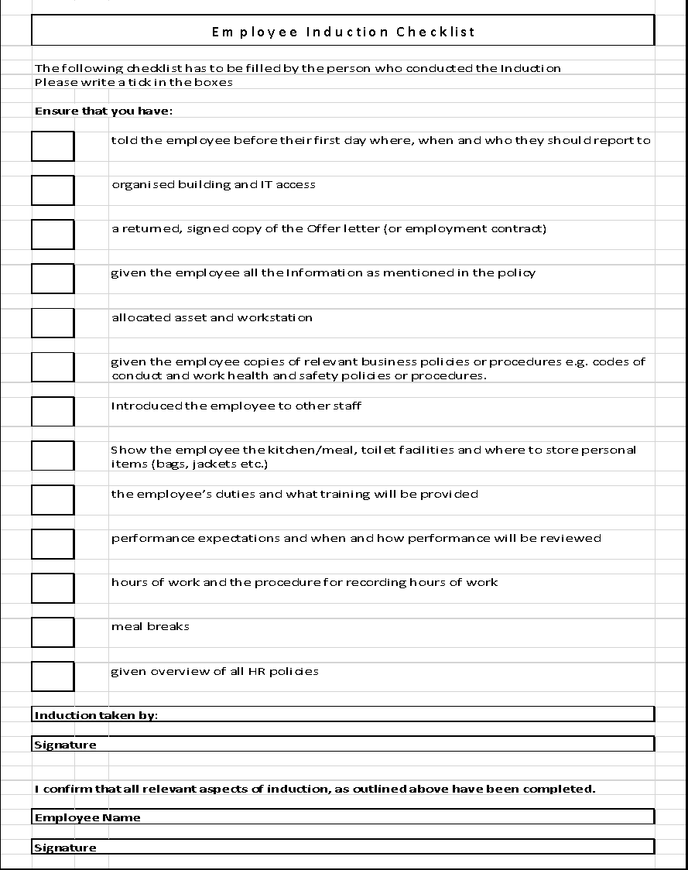
ANNEXURE 1

www.gspconsulting.com
______Disclaimer______
Please note this is a draft Policy prepared by GSPU Group for your reference. You may amend it suiting your requirement. GSPU Group expressly disclaims any liability arising out of the reliance on this draft.

